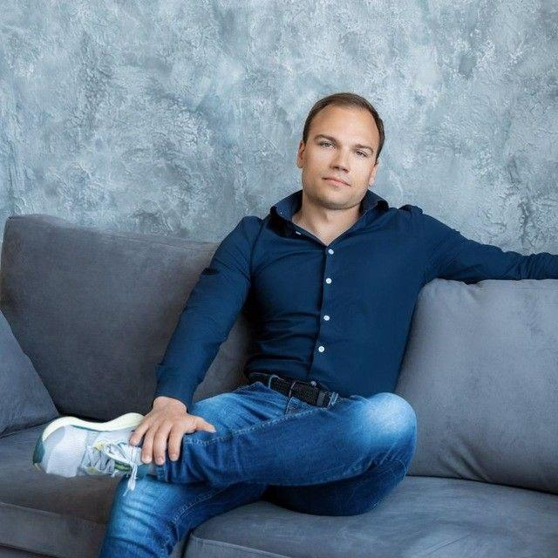**Alex Pudov**

**Senior Backand Engineer (Rust)**

**Experience:** Crypto, Fintech, Banking, Startups

**Education:** Bachelor’s degree | **English:** B2

[**pudo-aleksej@yandex.ru**](mailto:pudo-aleksej@yandex.ru)| +7-909-685-03-06 | [**LinkedIn**](https://www.linkedin.com/in/alexpudov/)| [**Git**](https://github.com/PudovAlexey)

**Location:** Belgrade, Serbia (ready to relocate)

**SUMMARY**

Software Engineer with **5+ years of experience** designing impactful solutions that streamline workflows, optimize performance, and enhance user experiences. At Sheremetyevo International Airport, delivered award-winning systems, including a Gantt chart with adaptive compression (**reducing** **response times by 30%**) and a digital twin service recognized at CIPR 2024.

Skilled in React, TypeScript, Redux, and REST APIs, with expertise in system architecture and UI design. Proven leader in team mentorship, recruitment standardization, and fostering collaboration. Passionate about solving complex challenges and driving results through technical excellence and innovation.

**SKILLS**

**Frontend stack:** JavaScript, TypeScript, React, React Native, Webpack, Vite, Redux, Redux Saga, Zustand, Jotai, Material-UI, Ant Design, RTK Query, TanStack, Vercel, GraphQL, REST, gRPC, Swagger, Conva, Canvas, Three.js, Leaflet, 2GIS, Animate.

**Backend Stack:** Rust, Actix Web, Axum, Tower, Tokio, REST, gRPC, GraphQL, Serde, Utopia, PostgreSQL, Elasticsearch, Kafka, Socket.io, Apache, Diesel orm, sqlx.

**PROFESSIONAL EXPERIENCE**

**Senior Backend Developer (Rust), Crypto Startup**

A cryptocurrency trading terminal platform (startup)

July 2024 - till now

* Developed a cryptocurrency trading terminal platform for buying and selling cryptocurrency.
* Built APIs using Actix Web framework. Implemented JWT-based user authentication middleware.
* Developed smart contracts for Solana asset acquisition and referral competitions.
* Integrated Telegram mini-apps for application functionality.
* Created user profile features: wallet connection, balance retrieval, and payment client setup.

**Achievements:**

1. Launched a Telegram-integrated trading terminal in less than 1 month.
2. Improved user registration security with seed phrase generation and password recovery, **reducing** account recovery **issues by 24%.**
3. Delivered a backend with secure authentication and optimized APIs.
4. Developed smart contracts for Solana transactions and user referral growth; as a result, it **increased** the platform **user base by 19%.**

**Senior Backand Engineer (Rust),** [**Sheremetyevo Handling**](https://gh.svo.aero/home)

Sheremetyevo International Airport is the biggest airport in Russia

July 2023 – July 2024

* Effectively assumed leadership responsibilities during the lead’s absence (vacation and illness), successfully managing **5+ team members**, delegating tasks, conducting **100+ final code reviews**, and maintaining seamless communication with the client.
* Facilitated the coordination and preparation of contracts with the frontend development team to optimize HTML rendering and integrate Konva and Apache ECharts technologies, effectively reducing unnecessary mappings and enhancing project efficiency across more than three ongoing initiatives, **resulting in a 20% reduction in time-to-market (TTM)** compared to other projects..
* Optimized faceted filtering performance, achieving a **10x optimization** and reducing response time to **0.75 seconds** under stable internet conditions, significantly improving user experience.
* Performed a comprehensive database audit, identified bottlenecks, and collaborated with the team lead to rewrite and optimize key queries, resulting in a **4x reduction in database query** volume and improved system efficiency.

**Senior Frontend Developer,** [**Sberbank**](http://sberbank.com/)

Sberbank is the largest bank in Central and Eastern Europe

March 2023 – August 2023

* Simplified and accelerated testing processes by integrating and implementing an admin panel for testing pop-up hints and the refueling flow during order execution, **reducing** tester **workload from 2–3 hours to 10 minutes.**
* Grew application performance by proposing and implementing an optimized algorithm for virtualizing the refueling history list, improving data slice delivery speed **from 1 second to 0.3 seconds.**
* Contributed to the user experience by designing robust functionality for managing and interacting with refueling stations, driving efficiency in development and testing workflows.

**Frontend Engineer,** [**Alar Studios**](http://www.alarstudios.com/)

Software solutions design and development agency for start-ups, gaming, and banking

April 2022 – March 2023

* Increased rendering **performance by over 30%** through comprehensive code refactors, employing techniques such as virtualization, useMemo, useCallback hooks, and lightweight data mappers.
* Conducted a regression test across **50+ application components,** identifying 10+ performance bottlenecks, resulting in a **16% improvement** in overall rendering performance.
* Delivered a robust and scalable admin panel, dynamically optimizing and managing 100+ user activities (games, quizzes, etc.), **improving administrative efficiency by 22%.**

**Frontend Developer,** [**Unicon**](https://unicon.ru/)

Unicon is Russia's largest audit and consulting group of companies, founded in 1989

April 2019 – April 2022

* Improved document management efficiency by implementing automated workflows and hierarchical structures, reducing manual effort by 40%.
* Improved report generation and export capabilities, enabling seamless document sharing and integration with other systems.
* **Reduced system latency by 20%** through targeted performance optimizations.
* **Mentored 3+ interns**, contributing to their professional growth and team productivity.

**EDUCATION**

2019 – Russian State University of Justice, Bachelor's Degree, Economy